**GURU NANAK DEV ENGINEERING COLLEGE, LUDHIANA**

**MEAN Full Stack Web Development**

**Assignment 2**

**(PEIT-109)**



**Submitted By:** **Submitted to:**

Name: Simardeep Singh Prof. Jagdeep Singh

Class: D3ITB2

CRN: 2021108

URN: 2004988

**Department of Information Technology,**

**Guru Nanak Dev Engineering College**

**Ludhiana-141106**

**Part A**

1. **Develop a single page application using Angular that includes a navigation bar. Discuss the importance of having navigation in a web application and explain how you can add navigation to your Angular application.**

**Ans:** React single page application code with navbar:

* Homescreen.js:

import React, { useEffect, useState} from 'react';

import axios from 'axios';

import Room from '../components/Room';

import moment from 'moment'

import Loader from '../components/Loader';

import Error from '../components/Error';

import { DatePicker, Space } from 'antd';

const Homescreen = () => {

const [data, setData] = useState([])

const[loading , setloading] = useState()

const[error , seterror] = useState()

const { RangePicker } = DatePicker;

const[fromdate, setfromdate]=useState()

const[todate, settodate]=useState()

useEffect(() => {

const fetchData = async () =>{

try {

setloading(true)

const {data: response} = await axios.get('/api/rooms/getallrooms');

setData(response);

setloading(false)

} catch (error) {

seterror(true)

console.error(error.message);

setloading(false)

}

}

fetchData();

}, []);

function filerByDate(dates){

// console.log(moment(dates[0].format('YYYY-MM-DD')).\_i)

// console.log(moment(dates[1].format('YYYY-MM-DD')))

setfromdate(moment(dates[0].format('YYYY-MM-DD')).\_i)

settodate(moment(dates[1].format('YYYY-MM-DD')).\_i)

}

return (

<div className='container'>

<div className='row mt-5' >

<div className='col-md-3'>

<RangePicker format='YYYY-MM-DD' onChange={filerByDate} />

</div>

</div>

<div className='row justify-content-center mt-5'>

{loading ? (

<h1><Loader/></h1>

) : data.length>1 ? (

data.map((rooms)=>{

return <div className='col-md-9 mt-3'>

<Room rooms={rooms} fromdate={fromdate} todate={todate} />

</div>;

})

) : (

<error/>

)}

</div>

</div>

)

}

export default Homescreen;

* Navbar.js:

import React from 'react'

import navbar from './navbar.css'

function Navbar() {

const user = JSON.parse(localStorage.getItem('currentUser'));

function logout() {

localStorage.removeItem('currentUser')

window.location.href = '/login'

}

return (

<div>

<nav class="navbar navbar-expand-lg">

<a class="navbar-brand" href="/home">Book It Up!</a>

<button class="navbar-toggler" type="button" data-toggle="collapse" data-target="#navbarNav" aria-controls="navbarNav" aria-expanded="false" aria-label="Toggle navigation">

<span class="navbar-toggler-icon" >

<i class="fa fa-hamburger" style={{ color: "white" }}>

</i>

</span>

</button>

<div class="collapse navbar-collapse" id="navbarNav">

<ul class="navbar-nav mr-auto">

{user ? (

<>

<div class="dropdown">

<button class="btn btn-secondary dropdown-toggle" type="button" data-bs-toggle="dropdown" aria-expanded="false">

<i className='fa fa-user'></i>{user.name}

</button>

<ul class="dropdown-menu">

<li><a class="dropdown-item" href="/profile">Profile</a></li>

<li><a class="dropdown-item" href="#" onClick={logout}>Log out</a></li>

</ul>

</div>

</>

) : (

<>

<li class="nav-item active">

<a class="nav-link" href="/register">Register</a>

</li>

<li class="nav-item">

<a class="nav-link" href="/login">Login</a>

</li></>)}

</ul>

</div>

</nav>

</div>

)

}

export default Navbar

Output:

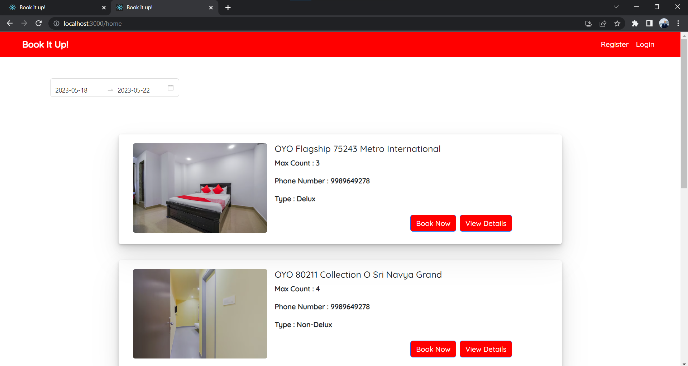

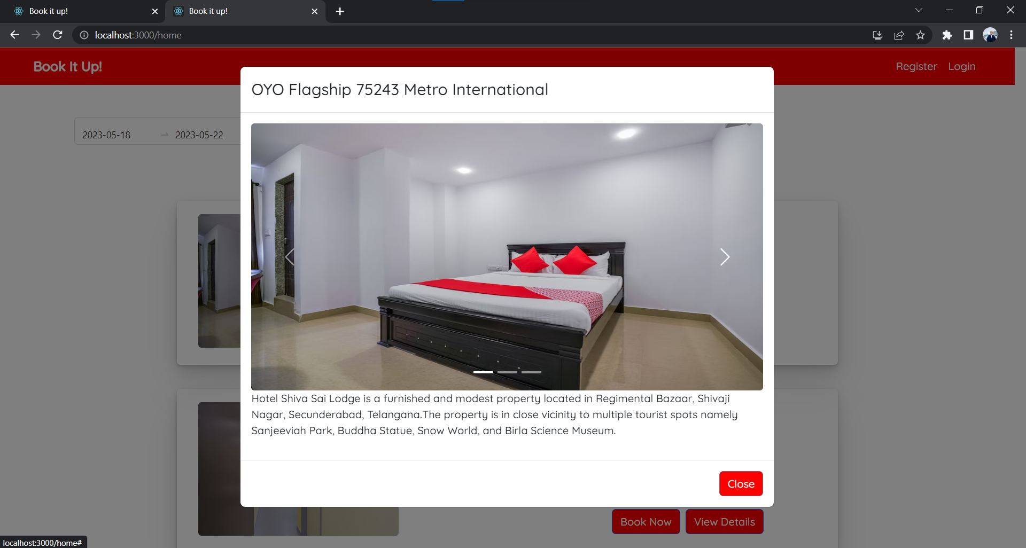

Navigation plays a crucial role in web applications as it enables users to move between different sections, pages, or views within an application. It provides a seamless and intuitive way for users to explore and interact with the application's content and functionality.Here are the key reasons why navigation is important in a web application:

* Enhances User Experience
* Improves Content Discoverability
* Facilitates Task Completion
* Supports Information Hierarchy
* Enables Context Switching

1. **Building a modular app is crucial in Angular development. Discuss the advantages of building a modular app and explain how you can create a modular app in Angular.**

Ans: In Angular, creating a modular app is essential for a number of reasons. Let's talk about the benefits of developing a modular app and explain how to can create a modular app in Angular:

Advantages of Building a Modular App in Angular:

1. Code Organization: By breaking your app into modules, you can organize your codebase more effectively. Modules provide clear boundaries and encapsulation, making it easier to locate and manage specific code related to a particular feature or functionality.
2. Maintainability: Modularity allows you to break down your application into smaller, self-contained modules. Each module can focus on a specific feature or functionality. Developers can work on different modules independently without affecting other parts of the application.
3. Scalability: Modular apps enable scalability by providing a flexible structure. As your application grows, you can add or remove modules as needed.
4. Reusability: With modular architecture, you can create reusable components, services, and modules.
5. Lazy Loading: Angular supports lazy loading, which is loading modules on-demand when they are required rather than loading the entire application upfront. It improve initial loading time of your application.

Creating a Modular App in Angular:

1. Create a new Angular Application: Using the following command, we can quickly create an angular app:

ng new appname

1. Create the main module: Go inside our project folder. We want to use the Angular CLI command to create a module after we’ve correctly created the app. In an angular application, angular gives a command to construct a module with routing. So, to create the main module, run the command below:

ng g module main --routing

After running the successful above command, it will create two files in the new folder name as main inside the app folder.

1. Import-module to module.ts file: We simply import our module into the app.module.ts file.

**3.Binding HTML content is an essential task in Angular development. Discuss the different types of data binding available in Angular and explain any one.**

Ans: Data binding allows Internet users to manipulate web page elements with the help of a web browser. It includes dynamic HTML and does not require complex programming. Data binding is used in web applications that contain interactive components such as forms, calculators, tutorials, and games.

Types of Data Binding:

i)Interpolation Binding

Interpolation is a procedure that allows the user to bind a value to the user interface element. Interpolation binds the data one-way, which means that data moves in one direction from the components to HTML elements.



ii) Property Binding:

Property binding is a one-way data binding mechanism that allows you to set the properties for HTML elements. It involves updating a property value in the component and binding the value to an HTML element in the same view. We use property binding for toggle functionality and sharing data between components. It uses the "[]" syntax for data binding.

iii) Event Binding:

Event binding type is when information flows from the view to the component when an event is triggered. The event could be a mouse click or keypress. The view sends the data to update the component. Unsurprisingly, it is the exact opposite of property binding, where the data goes from the component to the view.

IMG_256

iv)Two-way Data Binding

As the name suggests, two-way binding is a mechanism where data flows from the component to the view and back. This binding ensures that the component and view are always in sync. Any changes made on either end are immediately reflected on both. The general syntax to denote two-way data binding is a combination of Square brackets and parentheses "[()]".

IMG_256

Example:

In your component:

typescript

public name: string = 'John Doe';

In your template:

<input [(ngModel)]="name" type="text">

<p>Hello, {{ name }}!</p>

The [(ngModel)]="name" binds the value of the <input> element to the name property of the component. Any changes in the input field will update the name property, and vice versa, any changes to the name property will update the input field.

Two-way data binding simplifies the synchronization of data between the component and the template, reducing the need for manual event handling and property updates.

1. **Routing is an important concept in Angular development. Discuss the benefits of using routing in an Angular application and explain how you can implement routing in your application.**

**Ans:**

Routing in Angular allows the users to create a single-page application with multiple views and allows navigation between them. Users can switch between these views without losing the application state and properties.

**Syntax**-

**HTML:**

<li><a routerLink="/about" >About Us</a></li>

<router-outlet></router-outlet>

**TS:**

{ path: 'about', component: AboutComponent }

**Benefits of Using Routing in an Angular Application:**

Single-Page Application (SPA) Experience: Angular's routing allows you to create a single-page application experience, even though your application may have multiple views or pages. When users navigate between different routes, Angular dynamically updates the content without requiring a full page reload. This improves performance and provides a seamless user experience.

Modular and Reusable Components: Routing facilitates the modularization of your application into smaller, reusable components. Each route can be associated with a specific component, allowing you to build independent components that encapsulate different functionalities or views. This modularity promotes code organization, maintainability, and reusability across different routes and views.

URL-Based Navigation: Routing in Angular enables URL-based navigation, allowing users to directly access specific views within your application. Each route corresponds to a unique URL, making it possible to bookmark or share URLs to provide direct access to a particular page or state. This improves usability and search engine optimization (SEO) by enabling deep linking.

Lazy Loading: Angular's routing supports lazy loading, which is the practice of loading modules and their associated components only when they are needed. With lazy loading, you can split your application into smaller modules and load them on-demand, reducing the initial loading time. This is especially beneficial for large applications with numerous features, as it optimizes the performance by loading only the necessary resources.

**Implementing Routing in an Angular Application:**

**To implement routing in an Angular application, you can follow these steps:**

1.Set up the Angular Router: Import the necessary routing modules from @angular/router in your application's main module file (e.g., app.module.ts). Configure the routes by defining an array of route objects, each containing a path and the corresponding component to load.

**Code-**

import { NgModule } from '@angular/core';

import { HomeComponent } from './home.component'

import { ProductComponent } from './product.component'

import { AboutComponent } from './about.component'

import { ContactComponent } from './contact.component'

import { AppRoutingModule } from './app-routing.module';

import { AppComponent } from './app.component';

@NgModule({

declarations: [

AppComponent,

HomeComponent,

ProductComponent,

AboutComponent,

ContactComponent

],

imports: [

AppRoutingModule,

],

providers: [],

bootstrap: [AppComponent]

})

export class AppModule { }

1. Define Router Outlet: In your application's main HTML template (e.g., app.component.html), add a <router-outlet></router-outlet> tag. This acts as a placeholder that dynamically renders the component associated with the current route.

<span>

**Code** - <ul>

<li><a routerLink="/" >Home</a></li>

<li><a routerLink="/products" >Products</a></li>

<li><a routerLink="/about" >About Us</a></li>

<li><a routerLink="/contact" >Contact Us</a></li>

</ul>

</span>

<router-outlet></router-outlet>

4.Create Components: For each route, create a corresponding component that represents the view or functionality associated with that route. These components will be loaded dynamically when their respective routes are activated.

5.Set up Navigation Links: Add navigation links in your application's templates (e.g., Example:

import { ActivatedRoute } from '@angular/router';

constructor(private route: ActivatedRoute) {}

ngOnInit() {

// Accessing route parameters

const id = this.route.snapshot.paramMap.get('id');

// Accessing query parameters

const sort = this.route.snapshot.queryParamMap.get('sort');

// Accessing fragment parameter

const fragment = this.route.snapshot.fragment;

header or sidebar) using the <a> tag or Angular's routerLink directive. Assign the appropriate route path to the routerLink attribute to navigate to the desired view or component.

6.Configure Route Parameters and Data: Angular's routing supports passing parameters through the URL, such as IDs or query strings. You can define route parameters in the route configuration and access them in the corresponding component using ActivatedRoute service. Additionally, you can pass custom data to routes for further customization or configuration.

**Code**- import { NgModule } from '@angular/core';

import { Routes, RouterModule } from '@angular/router';

import { HomeComponent } from './home.component'

import { ProductComponent } from './product.component'

import { AboutComponent } from './about.component'

import { ContactComponent } from './contact.component'

const routes: Routes = [

{ path: '', component: HomeComponent },

{ path: 'products', component: ProductComponent },

{ path: 'about', component: AboutComponent },

{ path: 'contact', component: ContactComponent, },

];

@NgModule({

imports: [RouterModule.forRoot(routes)],

exports: [RouterModule],

providers: []

})

export class AppRoutingModule { }

So now run this using “ng serve” in CLI and open localhost://4200 in the browser here you see your navigation bar, and you can navigate from one component to another without page reload.

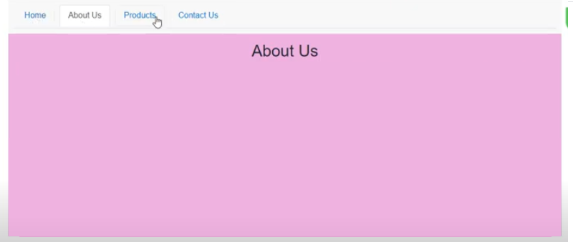

**5.Routing parameters are useful in passing data between components in an Angular application. Discuss the different types of routing parameters in Angular and explain how you can use them in your application**

**Ans-**In Angular, routing parameters are a powerful feature that allows you to pass data between components when navigating through routes. They enable dynamic and personalized views by providing contextual information to components. Angular supports different types of routing parameters, including route parameters, query parameters, and fragment parameters. Let's discuss each type and how you can use them in your application.

**Route Parameters:**

Route parameters are used to pass data within the route URL itself. They are denoted by a colon (:) followed by the parameter name. Route parameters are useful when you want to identify a specific resource or item in your application.

**Example:**

Route definition: { path: 'users/:id', component: UserComponent }

In this example, the id parameter is defined as part of the route URL. When navigating to a URL like /users/123, the 123 value will be available in the id parameter of the UserComponent. You can access the parameter value using the ActivatedRoute service in the component.

**Query Parameters:**

Query parameters are used to pass data as key-value pairs in the URL. They are appended to the URL after a question mark (?) and can be separated by ampersands (&) if multiple parameters are present. Query parameters are typically used for filtering, sorting, or providing additional options to a view.

**Example:**

URL: /users?id=123&sort=name

In this example, the query parameters id and sort are present in the URL. You can access the query parameters in your component using the ActivatedRoute service or the Router service. For example, you can retrieve the id parameter using this.route.snapshot.queryParamMap.get('id').

**Fragment Parameters**:

Fragment parameters, also known as hash parameters or anchors, are used to navigate to a specific section or element within a page. They are denoted by a hash (#) followed by the parameter value. Fragment parameters are useful for creating bookmarkable links within a single page.

**Example**:

URL: /users#section1

In this example, the fragment parameter section1 is appended to the URL. You can access the fragment parameter using the ActivatedRoute service. For example, this.route.snapshot.fragment will return 'section1'.

To use these routing parameters in your Angular application, you can follow these steps:

1.Define your routes in the routing module, specifying the desired parameter type (route, query, or fragment) in the route path.

2.Access the parameters in the target component by injecting and using the ActivatedRoute service. You can retrieve the parameter values from the snapshot property or by subscribing to the params or queryParamMap observables.

}

**Part-B**

1. **Working with forms is an essential task in Angular development. Discuss the different types of forms available in Angular and explain any one.**

**Ans-**

Introduction to forms in Angular

Handling user input with forms is the cornerstone of many common applications. Applications use forms to enable users to log in, to update a profile, to enter sensitive information, and to perform many other data-entry tasks.

Angular provides two different approaches to handling user input through forms: reactive and template-driven. Both capture user input events from the view, validate the user input, create a form model and data model to update, and provide a way to track changes.

This guide provides information to help you decide which type of form works best for your situation. It introduces the common building blocks used by both approaches. It also summarizes the key differences between the two approaches, and demonstrates those differences in the context of setup, data flow, and testing.

In Angular, there are two main types of forms available for working with user input: Template-driven forms and Reactive forms

**1.Template-driven Forms:**

Template-driven forms rely on Angular's directives and two-way data binding to handle form input and validation. With this approach, the form structure and behavior are defined in the template, and Angular infers the form controls and validation rules based on the template's markup.

**2.Reactive Forms:**

Reactive forms are based on a reactive programming style using explicit form control objects and reactive transformations. With reactive forms, the form structure and behavior are defined programmatically in the component class, offering more flexibility and control over form handling and validation.

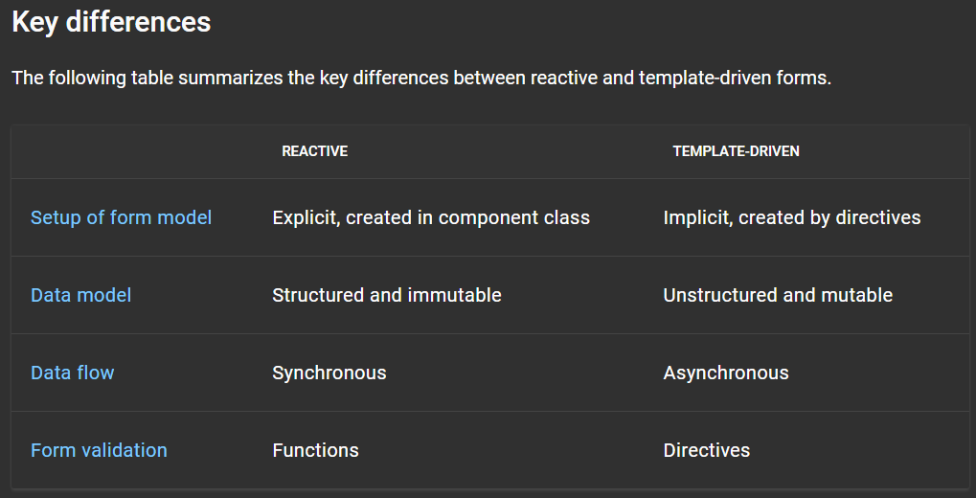

**Setting up the form model**

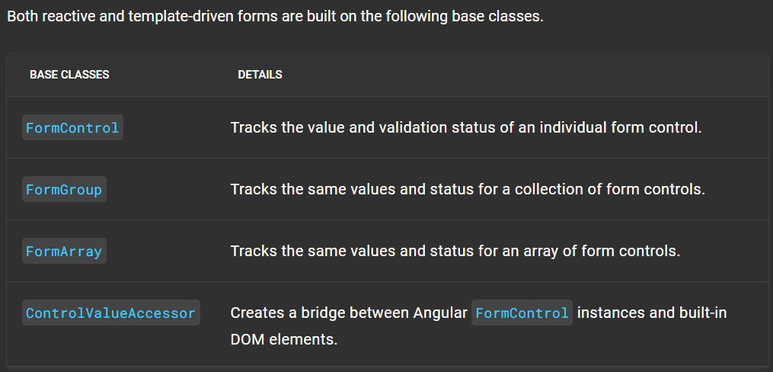

**Setup in reactive forms**

With reactive forms, you define the form model directly in the component class. The [formControl] directive links the explicitly created FormControl instance to a specific form element in the view, using an internal value accessor.

The following component implements an input field for a single control, using reactive forms. In this example, the form model is the FormControl instance.

**Example-**

content\_copy

import { Component } from '@angular/core';

import { FormControl } from '@angular/forms';

@Component({

selector: 'app-reactive-favorite-color',

template: `

Favorite Color: <input type="text" [formControl]="favoriteColorControl">

`

})

export class FavoriteColorComponent {

favoriteColorControl = new FormControl('');

}

Figure 1 shows how, in reactive forms, the form model is the source of truth; it provides the value and status of the form element at any given point in time, through the [formControl] directive on the element input

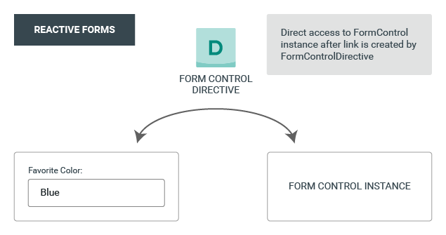

Figure.1

1. **Handling submitted data is a critical part of Angular development. Discuss the different ways you can handle submitted data in an Angular application and explain how you can implement each one.**

**Ans-** In an Angular application, there are different ways to handle submitted data from forms. The method you choose depends on factors such as the complexity of your application, the need for validation, and interaction with APIs. Here are the main approaches for handling submitted data in Angular:

**1.Template-driven Forms:**

Template-driven forms use Angular's ngModel directive to achieve two-way data binding between form controls and component properties. When a form is submitted, you can access the form data using the ngForm directive and handle it in a method defined in your component.

**Implementation steps:**

1.Add the ngForm directive to the form element in the template.

2.Use ngModel to bind form controls to component properties.

3.Implement a method in the component that receives the form data as a parameter when the form is submitted.

Example:

<form #myForm="ngForm" (ngSubmit)="onFormSubmit(myForm.value)">

<input type="text" name="name" [(ngModel)]="formData.name">

<button type="submit">Submit</button>

</form>

onFormSubmit(formData: any) {

// Handle the form data

console.log(formData);

}

**2.Reactive Forms:**

Reactive forms provide a more programmatic approach to form handling. You create form controls and groups in the component class and bind them to the form in the template. When the form is submitted, you can access the form data directly from the form object and handle it in your component.

**Implementation steps:**

* Create a FormGroup instance in the component to represent the form.
* Create FormControl instances for each form control.
* Bind the form group and form controls to the template using the formGroup and formControl directives.
* Implement a method in the component to handle the form submission, accessing the form data through the form group.

<form [formGroup]="myForm" (ngSubmit)="onFormSubmit()">

<input type="text" formControlName="name">

<button type="submit">Submit</button>

</form>

import { FormBuilder, FormGroup } from '@angular/forms';

// ...

myForm: FormGroup;

constructor(private formBuilder: FormBuilder) {

this.myForm = this.formBuilder.group({

name: ''

});

}

onFormSubmit() {

// Access form data

const formData = this.myForm.value;

console.log(formData);

}

**3.Using Angular Services:**

When dealing with complex form submissions involving data manipulation, validation, or interaction with APIs, it's common to use Angular services to handle the form data. Services encapsulate the logic related to form submission and provide a centralized place to handle the data.

**Implementation steps:**

* Create a service using the Angular CLI: ng generate service FormService.
* Implement the necessary methods in the service to handle the form submission.
* Inject the service into the component where the form is located.
* Call the service's methods when the form is submitted, passing the form data.

Example:

// form.service.ts

import { Injectable } from '@angular/core';

@Injectable({

providedIn: 'root'

})

export class FormService {

submitForm(formData: any) {

// Handle form submission logic, e.g., API calls, data manipulation

console.log(formData);

}

}

// component.ts

import { Component } from '@angular/core';

import { FormService } from './form.service';

1. **Explain the importance of unit testing in Angular development and discuss how you can write a unit test for your Angular application.**

**Ans-**

Unit testing is an essential aspect of Angular development that involves testing individual units of code, such as components, services, and directives, in isolation. Unit testing helps ensure that each unit of code behaves as expected and detects bugs or regressions early in the development process. Here are the reasons why unit testing is important in Angular development:

Early Bug Detection: Unit testing allows you to catch bugs early in the development cycle when they are easier and cheaper to fix.

Code Maintainability: Unit tests provide a safety net when making changes to your code. They act as documentation of the expected behavior of each unit and help prevent unintended side effects or regressions. When refactoring or adding new features, unit tests ensure that existing functionality remains intact.

Code Quality and Confidence: Writing unit tests encourages writing modular and testable code. It promotes good coding practices such as separation of concerns, dependency injection, and loose coupling. Having a comprehensive suite of passing unit tests gives developers confidence in the correctness of their code.

Collaboration and Continuous Integration: Unit tests facilitate collaboration among team members. Unit tests are also crucial for continuous integration and continuous delivery pipelines, where automated tests are executed to ensure code stability before deployment.

**To write a unit test for your Angular application, you can follow these steps:**

1.Set Up Testing Environment:

Angular provides a testing framework called Jasmine by default. Install the necessary testing packages by running the command ng add @angular/preset-angular if you haven't already.

2.Create a Test File:

For a component named MyComponent, create a my-component.component.spec.ts file next to the component file.

Import the necessary testing modules, including the TestBed and the component to be tested.

3.Write Test Cases:

Use the describe function to group related test cases.

Use the beforeEach function to set up the testing environment before each test case.

Use the it or test functions to write individual test cases.

Within each test case, set up the component, interact with it, and make assertions about its behavior.

Example:

import { TestBed, ComponentFixture } from '@angular/core/testing';

import { MyComponent } from './my-component.component';

describe('MyComponent', () => {

let component: MyComponent;

let fixture: ComponentFixture<MyComponent>;

beforeEach(async () => {

await TestBed.configureTestingModule({

declarations: [MyComponent]

}).compileComponents();

});

beforeEach(() => {

fixture = TestBed.createComponent(MyComponent);

component = fixture.componentInstance;

fixture.detectChanges();

});

it('should create the component', () => {

expect(component).toBeTruthy();

});

it('should display the correct title', () => {

component.title = 'Test Title';

fixture.detectChanges();

const element = fixture.nativeElement.querySelector('h1');

expect(element.textContent).toContain('Test Title');

});

});

4.Run Tests:

Execute the command ng test in the terminal to run the unit tests.

The testing framework will launch the test runner, execute the test cases, and provide feedback on the results.

Example:

Executed 2 of 2 SUCCESS (0.123 secs / 0.456 secs)

1. **Security is a crucial aspect of web development. Discuss the different security measures you can implement in your Angular application to ensure the security of user data.**

**Ans:**

Security is indeed a critical aspect of web development, and Angular provides several built-in features and best practices to enhance the security of your application and protect user data. Here are some security measures you can implement in your Angular application:

1.Secure Communication:

* Always use HTTPS: Ensure that your application is served over HTTPS to encrypt the communication between the client and the server. This prevents eavesdropping and data tampering.
* Enable HTTP security headers: Implement security headers such as Content Security Policy (CSP), X-XSS-Protection, X-Content-Type-Options, and X-Frame-Options to mitigate common web vulnerabilities.

2.Cross-Site Scripting (XSS) Prevention:

* Sanitize user input: When accepting user input, sanitize and validate it to prevent XSS attacks. Angular's built-in template engine automatically escapes interpolated values, providing some protection against XSS vulnerabilities.
* Use safe pipes: Angular provides safe pipes, such as DomSanitizer, which can be used to sanitize HTML and prevent the execution of potentially malicious scripts.

Cross-Site Request Forgery (CSRF) Protection:

3.Enable CSRF tokens: Protect your application against CSRF attacks by generating and validating CSRF tokens for every request that modifies data or performs sensitive operations. Angular provides built-in support for CSRF protection.

* Set CSRF protection on the server: Configure your server to set the CSRF token in cookies and validate it on each request.

4.Validate user input: Implement server-side and client-side validation to ensure that user-supplied data adheres to the expected format and prevents malicious input.

* Encode output: Use output encoding techniques (e.g., encoding special characters) to prevent cross-site scripting attacks when displaying user-generated content.

1. Implement secure authentication mechanisms:

Use industry-standard protocols such as OAuth 2.0 or JWT (JSON Web Tokens) to handle user authentication securely.

* Implement role-based access control (RBAC) or permissions: Define roles and permissions to control access to different parts of your application and protect sensitive resources.

**5.Discuss the benefits of using Angular for developing single page applications and explain how it compares to other front-end frameworks and libraries.**

**Ans-**

Angular is a popular front-end framework for developing single-page applications (SPAs) and offers several benefits over other front-end frameworks and libraries. Here are the key advantages of using Angular:

Comprehensive and Feature-Rich:

Angular is a comprehensive framework that provides a wide range of features and tools to build complex and scalable SPAs. It offers a complete solution for application development, including templating, data binding, dependency injection, routing, forms, and more, all integrated into a cohesive ecosystem.

Two-Way Data Binding:

Angular's two-way data binding simplifies the synchronization between the model (data) and the view (UI). It automatically updates the view when the model changes and vice versa, reducing the need for manual DOM manipulation and enabling real-time updates.

Component-Based Architecture:

Angular follows a component-based architecture, where the application is structured into reusable and modular components. This approach promotes code reusability, maintainability, and separation of concerns. Components encapsulate the HTML, CSS, and logic related to a specific part of the application.

Powerful Templating Engine:

Angular's templating engine provides a declarative approach to define the UI. The templates are written in HTML, making it easy to understand and collaborate with designers. Angular's templates support features like directives, data binding, event handling, and structural directives, enabling dynamic and interactive UI development.

Dependency Injection (DI):

Angular's built-in dependency injection system simplifies managing dependencies between different parts of an application. DI allows for loose coupling, better code organization, and easy testing by injecting dependencies into components, services, and other constructs.

Strong Community and Ecosystem:

Angular has a vibrant and active community of developers, which results in extensive documentation, tutorials, and resources available for learning and problem-solving. The Angular ecosystem also includes a rich set of libraries, tools, and third-party integrations that enhance productivity and extend the capabilities of Angular applications.

Mobile-Friendly and Cross-Platform:

Angular has built-in support for building mobile applications using frameworks like Ionic and NativeScript. With Ionic, developers can create hybrid mobile apps, while NativeScript enables the development of native mobile apps using Angular. Angular also supports server-side rendering (SSR) for improved performance and SEO.

Officially Supported by Google:

Angular is developed and maintained by Google, which ensures a high level of stability, regular updates, and long-term support. The backing of a reputable organization provides confidence in the framework's future and its alignment with industry standards and best practices.

When compared to other front-end frameworks and libraries, here's how Angular stands out:

* React: Angular and React are both popular choices for SPAs. While React focuses on the view layer, Angular provides a more comprehensive framework with built-in features like routing, forms, and dependency injection. Angular's two-way data binding simplifies development, whereas React relies on a unidirectional data flow. Angular's extensive ecosystem and official support make it a favorable choice for larger and enterprise-level applications.
* Vue.js: Vue.js is known for its simplicity and ease of integration with existing projects. It offers a gradual learning curve and provides reactive data binding similar to Angular. However, Angular offers a more complete solution, with a stronger emphasis on architecture, scalability, and tooling. Angular's rich feature set and extensive documentation make it well-suited for larger applications and enterprise projects.